**HOW TO USE JUNIT TESTS IN INTELLIJ TO TEST YOUR CODE**

1. Download the JUnit tester file that is in the folder. You will see an error because it doesn’t know what junit is. You need to add the junit package to the build tools.   
   1. Mouse over the red “junit” text and show the following context action.
   2. 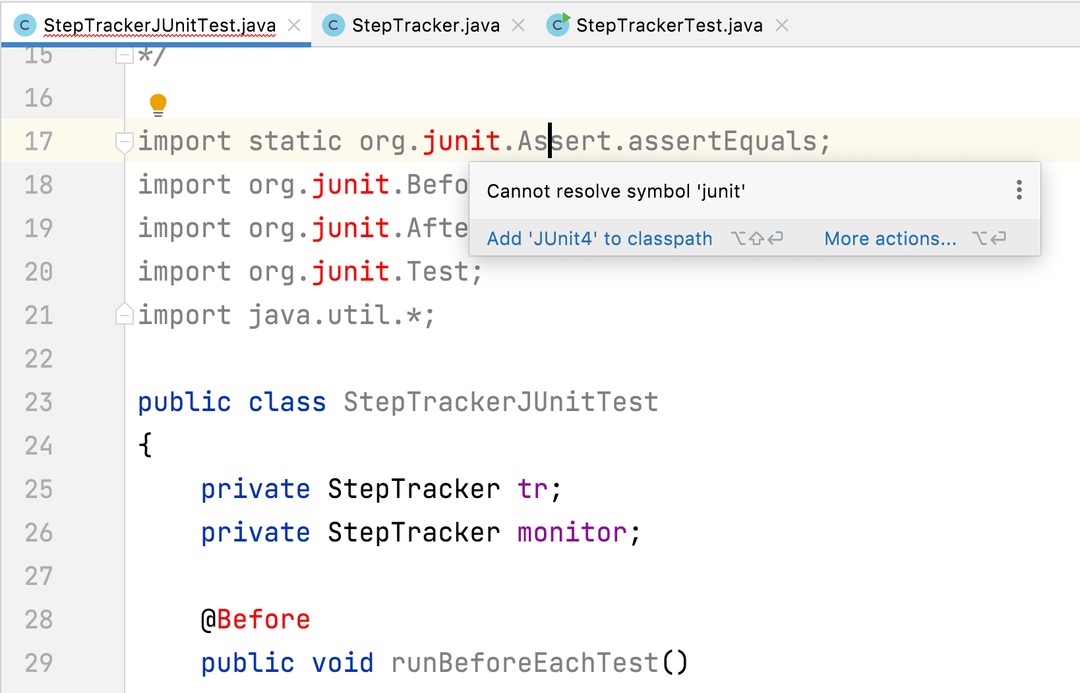
   3. Click “Add ‘JUnit4’ to classpath”, you will then see this window:

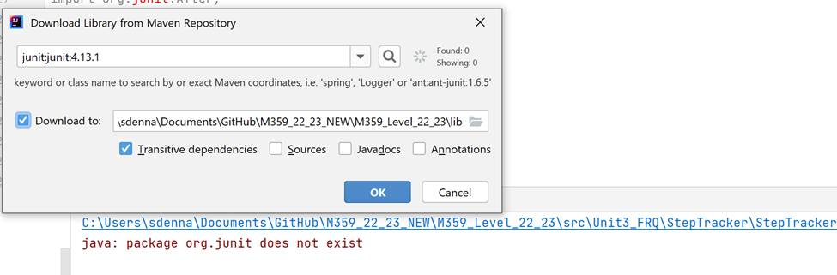

* 1. Click “OK”, then it should be ready to run.

**Testing your code**

1. To run a single test, click on the button next to the method header  
   
2. To run ALL the JUnit tests, click on this button next to the class header.

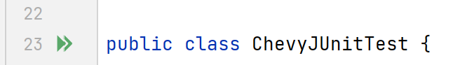

1. After passing ALL tests, you will see green checks telling you they passed.  
   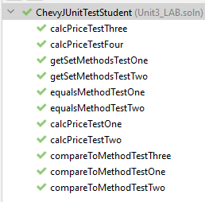
2. When some tests don’t pass, you will see a yellow x telling you where your code failed.  
   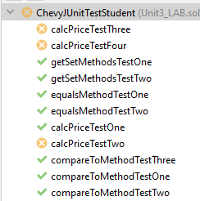
3. Looking at the error (difference from what was expected and what the actual answer was) you can troubleshoot the cause of the error.  
   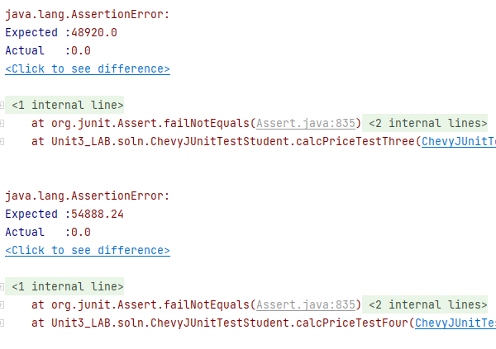
4. When you have fixed the code, and want to rerun it, this red icon shows us this test failed before, and now we can run it. You can click on this specific red circle/green arrow to **just this test**.

